**Adding a Sampling Point**

Use the menu on the left and under Water Systems select Sampling Points.

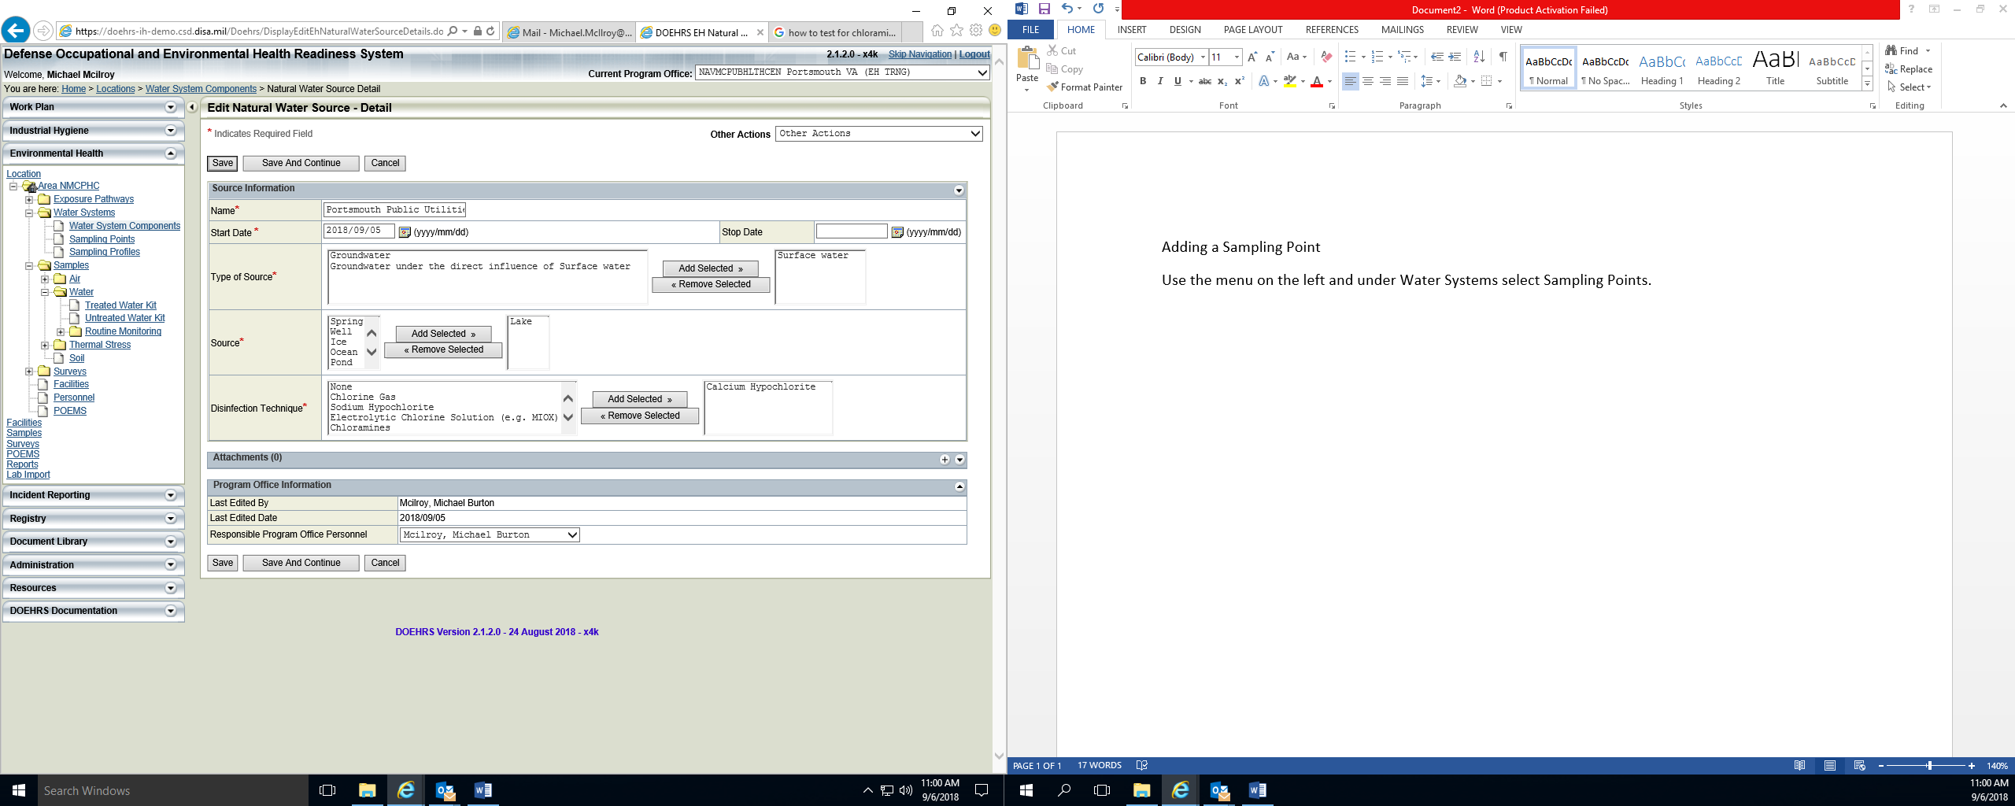

Using the + icon or ‘Other Actions’ pick list you will add a Sampling Point. Here you will need to complete required fields. You will need to have knowledge of the water ‘Treatment Type’ as well as the ‘Water System Component Type’ of your system. Select save when completed.

